APPENDIX A

A

Business Plan

On

**Book E-Rental Store System**

**Subject:** Major Project Market Analysis

**Professor:** Mr. Mudit Khetan and

Mr. Navneet Kumar Verma

**Submitted by:** Kishan Kumar

**Enrolment No-:** JNU-JPR/2013/00093

**School -: School of Engineering and Technology**

**Branch-: Computer Science and Engineering**

JAIPUR NATIONAL UNIVERSITY

**Business Plan:** To set up a Book E-Rental Store.

**Category:** E-Commerce

**Brand-:”** RUMOURS GROUP”

**Executive Summary and Opportunity Analysis**

Rumour is an online book rental store. Book E-Rental Store (BERS) will serve the used as well as brand new books and Members will have choice to order book of their choice online. BERS will have books for junior college students as well as Graduation level and Post- graduation level books and Novels. BERS will also have a Book Sections Like Competitive Exam (UPSC, AFCAT etc). BERS will serve students using their university data of recommended books and most preferred books in the university.

**Facility Provided by BERS-:**

1. Online Membership with Physical Verification.
2. Online catalogues
3. Competitive and Affordable deposits and Rental Facility to Purchase.
4. Members Pick up and Drop of Book (Delivery Facility Not Available).
5. Online Transaction Facility.
6. Easy return policy
7. Cash Payment on Pick up.
8. Loyalty Point.

BERS will be a combination of marketplace and general E-commerce business model.

BERS will operate as marketplace for the University books and competitive exam books will be stocked by BERS. So, a customer ordering the University Textbooks will access local bookstores online and will get the Pick Up Facility within 24 hours.

**Situational Analysis**

**Note: The Data of Analysis is Taken from AICTE Annual Report 2013.**

**Link-:** <http://mhrd.gov.in/sites/upload_files/mhrd/files/document-reports/AR2013-14.pdf>

**Market size and Future Projections:**

India is expected to have the third-largest number of internet users in the world by 2018. Statistics for the publishing industry are also promising. India is the world's third largest market for English books, and its entire book market in English, as well as regional Languages it is estimated to generate Rs. 10,000 crores annually. The online book market in India is expected to grow at 30–35% annually for the next five years till 2020.

**Political and Legal:**

**Economic:**

India is huge market for E-commerce. Indian population of internet users in 170 million and it’s ranked third highest number of internet population. The penetration is just 13%. So, E-commerce sector can grow with lot of speed.

The private education market in India was 5% and in terms of value was estimated to be worth US$40 billion in 2008 but had increased to US$68–70 billion by 2012.

As per the latest (2013) report issued by the All India Council of Technical Education (AICTE), there are more than 3524 diploma and post-diploma offering institutions in the country with an annual intake capacity of over 1.2 million. The AICTE also reported 3495 degree-granting engineering colleges in India with an annual student intake capacity of over 1.76 million with actual enrolment crossing 1.2 million. Capacity for Management Education crossed 385000 and post graduate degree slots in Computer Science crossed 100,000.

Pharmacy slots reached over 121,000. Total annual intake capacity for technical diplomas and

degrees exceeded 3.4 million in 2012.According to the University Grants Commission (UGC) total enrolment in Science, Medicine, Agriculture and Engineering crossed 6.5 million in 2010.

**Social:**

As per the Annual Status of Education Report (ASER) 2012, 96.5% of all rural children between the ages of 6-14 were enrolled in school. This is the fourth annual survey to report enrolment above 96%. 83% of all rural 15-16 year olds were enrolled in school.

However, going forward, India will need to focus more on quality. Gross enrolment at the tertiary level has crossed 20% (Ernst & Young Report cited in Jan 2013 in Education News/minglebox.com). So, along with private education market, educational awareness has increased in the country and more and more students are being enrolled in the schools.

**Technology:**

With the increase in the internet and mobile phone users, the serviceability of the ecommerce

business has increased comprehensively. Individuals are getting used with the ecommerce websites and payment methods. They are able to order the goods online and pay online as trust in the system has increased. For attracting users for the tier-2 or tier-3 cities, BERS will develop websites in Standard languages so, language would not be a barrier for online purchase.

**Competitive Review**

**SWOT Analysis of Online Book Rental System**

**Weakness**

Pick Up Policy

No Physical Contact with Book

**Strength**

Save Time and Human Effort

Variety of Rent Option at one Place.

Easy Return Policy

**Threat**

Increasing No of Book Readers.

Changing Syllabus of Institution’s.

Online Book Selling Giants.

**Opportunity**

Increase Number of Online Buyer

Loyalty Point.

**Competitive Analysis of other Operators**

There are two main competitors which are operating in the online book rental models are mentioned below. These two competitors are operating locally and have intention to grow nationwide.

|  |  |  |
| --- | --- | --- |
|  | **LazyWyre.com** | **RentMyText.com** |
| **Headquarters** | Mumbai | Bangalore |
| **Operating Since** | 2009 | 2012 |
| **Region of operation** | Mumbai | Bangalore and Mysore |
| **Growth** | Low | Moderate |
| **Strengths** | Quick service as operates in a single city | All books are stocked so  delivery system is good |
| **Weakness** | * Poor Website * Poor Marketing * Very low penetration | * Complicated GUI on Web |
| **Website** | www.lazywyre.com | www.rentmytext.com |

**Industrial Competitive analysis using Porter’s Five Forces Model**

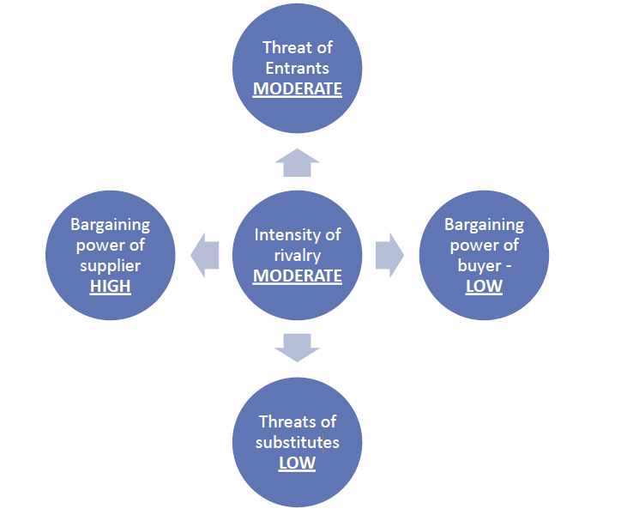

**Our Mission:**

―*To serve the customers by providing a reliable, accessible way to rent books at reasonable*

*Cost*.